AMERICAN HERDING BREEDS ASSN.
AND

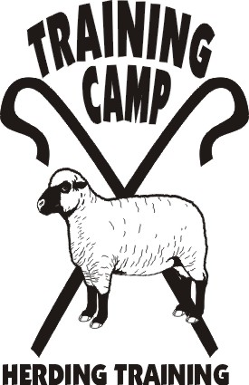

HERDING RANCH TRIAL
TRIAL CLASSES: HRD I, II, III – Sheep

April 27, 2012

LOCATION:

Seaman Farm, Chisago, MN

OPEN TO ALL HERDING AND MIXED HERDING BREEDS
(DOGS AT LEAST 6 MONTHS OF AGE)

ENTRY LIMITS: 10 RTD (Preference given to clinic participants)

MAIL ENTRIES TO: TRAINING CAMP, INC.
Julia Torgersen
5416 – 245th Street – Forest Lake, MN 55025

ENTRY FEES ALL CLASSES:
Clinic Participants $30/run
Day-Of (runs available) $40/run

TRIAL CHAIR: JoAnna Yund
JoAnnaY@aol.com

- Handlers Meeting for HRD will be at 121:30 p.m.
- Competitors are responsible for cleaning up after their dogs. All dogs must be on leash when not competing.
- Competitors assume financial responsibility for medication and/or veterinary care and/or replacement value of stock for any injury caused by them or their dog(s).

DIRECTIONS TO SITE – available at www.trainingcampinc.com

